**WS21 - Mongo DB Compass - Shell**

**DATE:** 23th December 2021

* 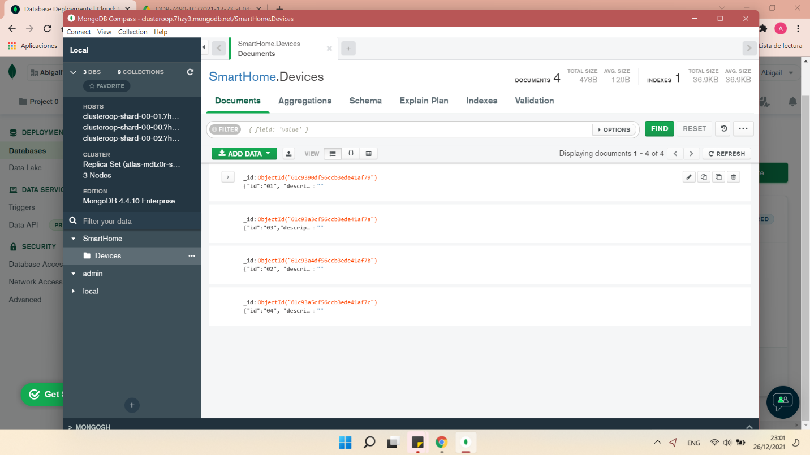**Mongo Compass**
* 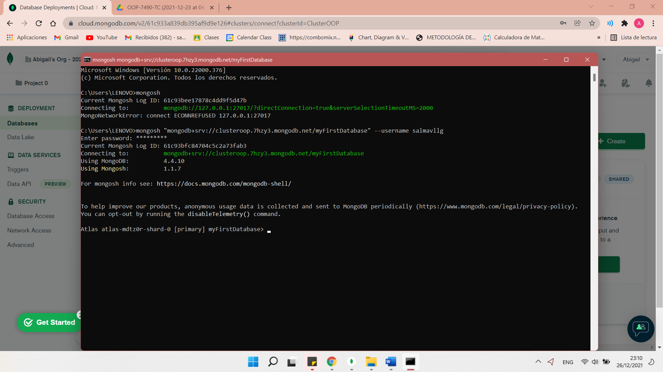**Mongo Shell**